Dot in the circle

**Problem Description:**

The task is simple, you are given a circle with **N** different regions. Where three radii divide the circle into **N** congruent regions. (You are more understood given picture for three regions)

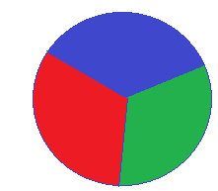

For example a dot hit this circle, where probability (hit the red region) is area of red region divide area of circle, green and blue region same as above.

Now find the probability of dot throw in a circle for getting any one region of any two adjacent / neighbor regions of this circle.

Input:

The first line contain a single integer **T (1<=T<=100)**, which denoted the number of test case. Each of the following **T** lines contain two integers **R** and **N (1<=R<=1000, 2<=N<=100)** –Radius of circle and number of regions. And print six digits after the decimal point.

Output:

For each test case print case number and probability.

Sample Input / Output:

|  |  |
| --- | --- |
| input | Output |
| 2  5 3  2 10 | Case 1 : 0.666667  Case 2 : 0.200000 |